Week 5: Hands-On
WebAPI Hands-On
Objective:
- Create a Chat Application which uses Kafka as a streaming platform and consume the chat messages in the command prompt.
- Create a Chat Application using C# Windows Application using Kafka and consume the message in different client applications
Setup:
Starting Zookeeper:
.\bin\windows\zookeeper-server-start.bat .\config\zookeeper.properties
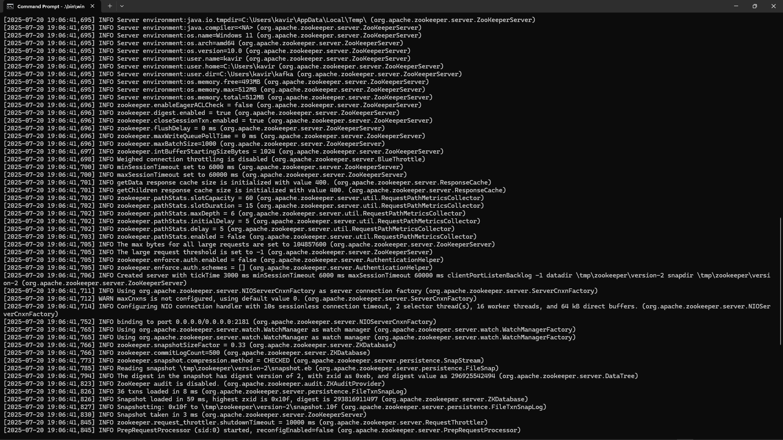

Starting Kafka Brkoer:
.\bin\windows\kafka-server-start.bat .\config\server.properties
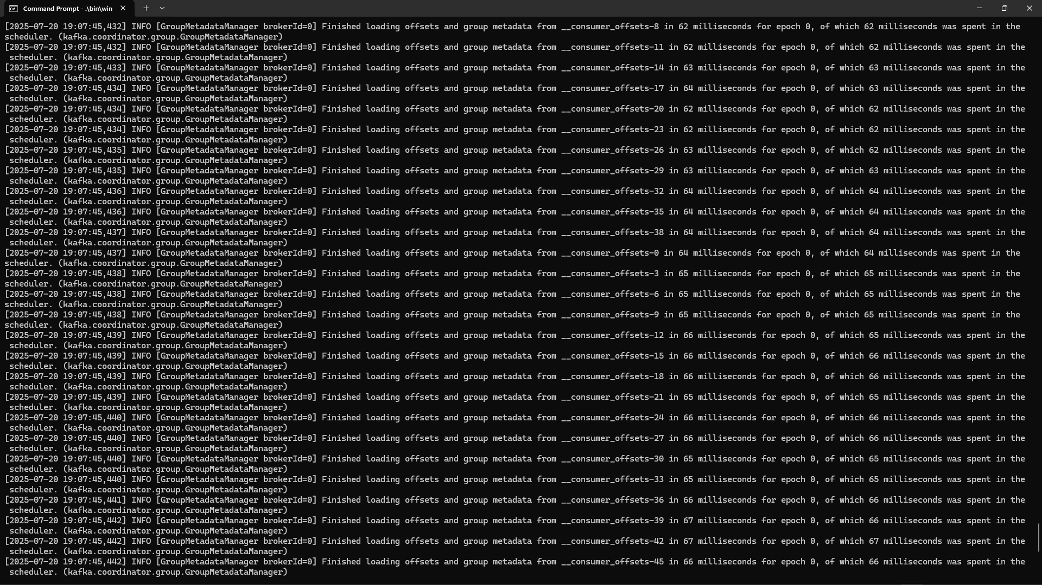
Creation Topic Chat:
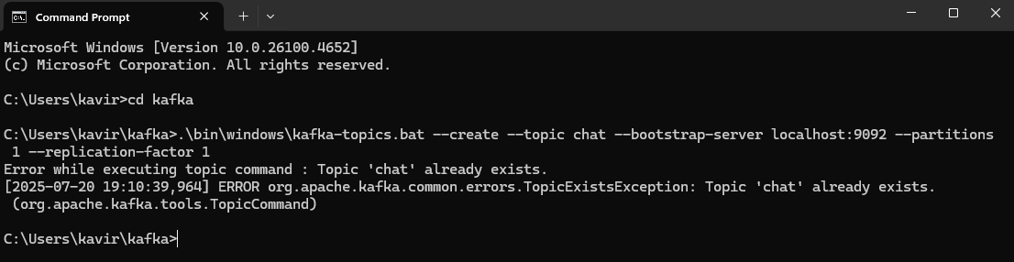

Project:
Kafka Producer:
Form1.cs
using Confluent.Kafka;
using System;
using System.Windows.Forms;
namespace KafkaChat
{
public partial class Form1 : Form
{
public Form1()
{
InitializeComponent();
}
private async void btnSend_Click(object sender, EventArgs e)
{
string message = textBox1.Text;
var config = new ProducerConfig
{
BootstrapServers = "localhost:9092"
};
using (var producer = new ProducerBuilder<Null, string>(config).Build())
{
var result = await producer.ProduceAsync("chat-message", new Message<Null, string> { Value = message });
MessageBox.Show($"Message sent to Kafka Topic: {result.TopicPartitionOffset}");
}
}
private void btnCancel_Click(object sender, EventArgs e)
{
this.Close();
}
}
}
Form1.Designer.cs
namespace KafkaChat
{
partial class Form1
{
private System.ComponentModel.IContainer components = null;

protected override void Dispose(bool disposing)
{
if (disposing && (components != null))
{
components.Dispose();
}
base.Dispose(disposing);
}
private void InitializeComponent()
{
this.label1 = new System.Windows.Forms.Label();
this.textBox1 = new System.Windows.Forms.TextBox();
this.btnSend = new System.Windows.Forms.Button();
this.btnCancel = new System.Windows.Forms.Button();
this.SuspendLayout();
this.label1.AutoSize = true;
this.label1.Location = new System.Drawing.Point(58, 45);
this.label1.Name = "label1";
this.label1.Size = new System.Drawing.Size(250, 20);
this.label1.TabIndex = 0;
this.label1.Text = "Please Enter Your Message Here:";
this.textBox1.Location = new System.Drawing.Point(62, 77);
this.textBox1.Multiline = true;
this.textBox1.Name = "textBox1";
this.textBox1.Size = new System.Drawing.Size(300, 150);
this.textBox1.TabIndex = 1;
this.btnSend.Location = new System.Drawing.Point(244, 259);
this.btnSend.Name = "btnSend";
this.btnSend.Size = new System.Drawing.Size(75, 41);
this.btnSend.TabIndex = 2;
this.btnSend.Text = "Send";
this.btnSend.UseVisualStyleBackColor = true;
this.btnSend.Click += new System.EventHandler(this.btnSend_Click);
this.btnCancel.Location = new System.Drawing.Point(86, 259);
this.btnCancel.Name = "btnCancel";
this.btnCancel.Size = new System.Drawing.Size(75, 41);
this.btnCancel.TabIndex = 3;
this.btnCancel.Text = "Cancel";
this.btnCancel.UseVisualStyleBackColor = true;
this.btnCancel.Click += new System.EventHandler(this.btnCancel_Click);
this.AutoScaleDimensions = new System.Drawing.SizeF(9F, 20F);
this.AutoScaleMode = System.Windows.Forms.AutoScaleMode.Font;
this.ClientSize = new System.Drawing.Size(1265, 755);
this.Controls.Add(this.btnCancel);
this.Controls.Add(this.btnSend);
this.Controls.Add(this.textBox1);
this.Controls.Add(this.label1);
this.Name = "Form1";
this.Text = "Kafka Chat Producer";
this.ResumeLayout(false);
this.PerformLayout();

}
private System.Windows.Forms.Label label1;
private System.Windows.Forms.TextBox textBox1;
private System.Windows.Forms.Button btnSend;
private System.Windows.Forms.Button btnCancel;
}
}

Kafka Consumer:
.\bin\windows\kafka-console-consumer.bat --topic chat --from-beginning --bootstrap-server localhost:9092
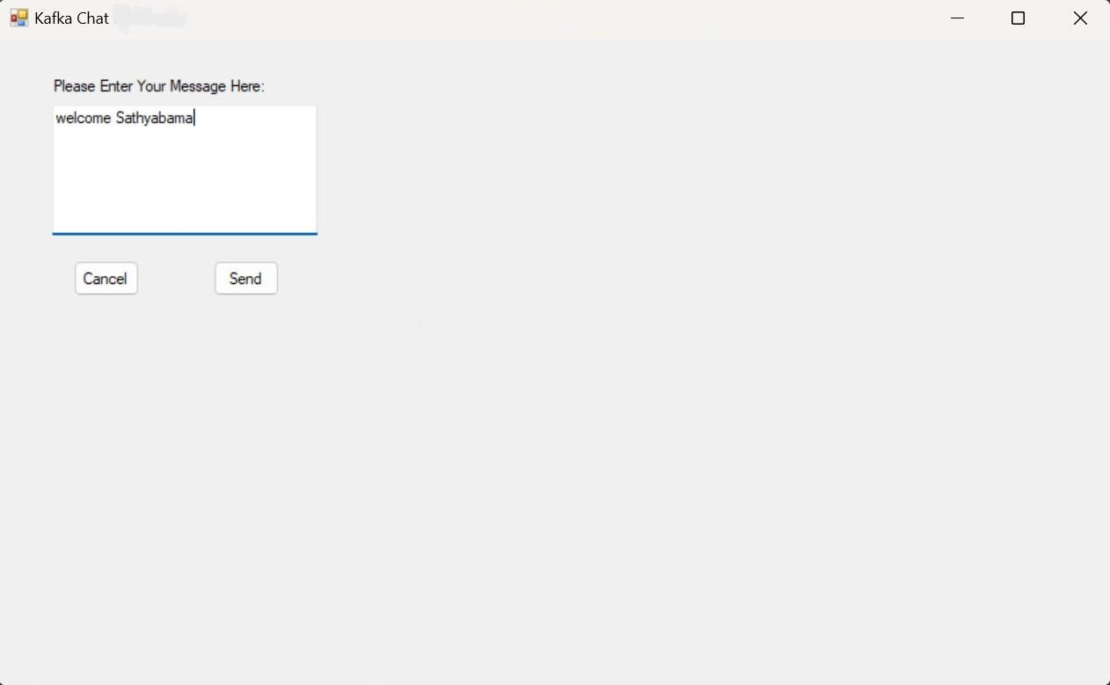

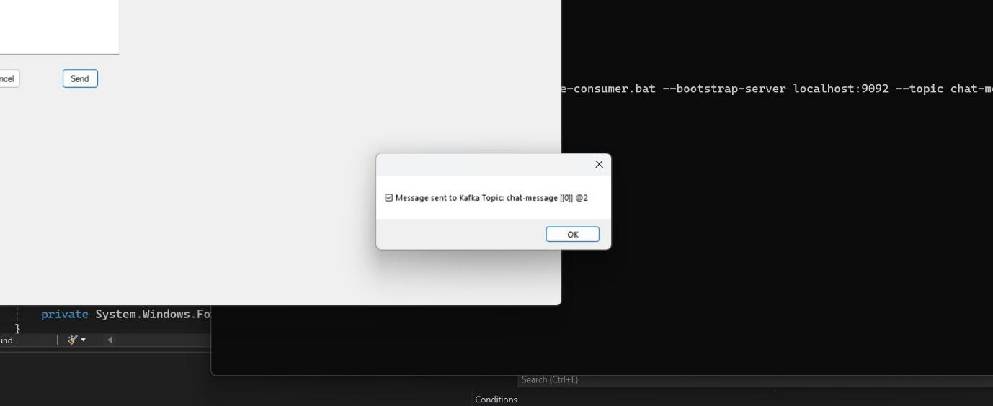

Output:
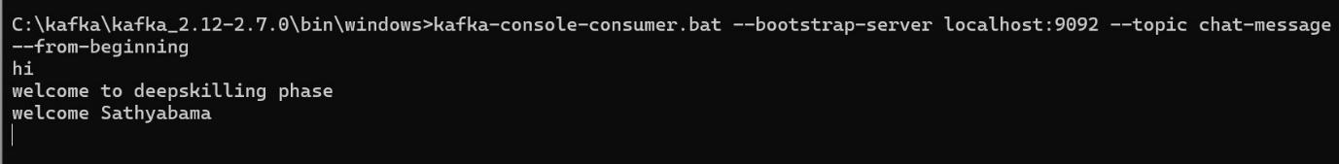
---------------------------------------------------------------------------------------------------------
Microservices
Authentication and Authorization in ASP.NET Core Web API Microservices
Objective:
Implement and secure ASP.NET Core Web API microservices using JWT authentication and role-based authorization. Learn how to generate and validate JWT tokens, protect endpoints with [Authorize], enforce role-based access, and handle token expiry with custom responses.
Project:
appsettings.json
{
"Jwt": {
"Key": "ThisIsAVerySecretKeyTokenForAdmin",
"Issuer": "MyAuthServer",
"Audience": "MyApiUsers",
"DurationInMinutes": 60
},
"Logging": {
"LogLevel": {
"Default": "Information",
"Microsoft.AspNetCore": "Warning"
}
},
"AllowedHosts": "*"
}
Program.cs
using JwtAuthDemo.Services;
using Microsoft.AspNetCore.Authentication.JwtBearer;
using Microsoft.IdentityModel.Tokens;
using Microsoft.OpenApi.Models;
using System.Text;
var builder = WebApplication.CreateBuilder(args);
builder.Services.AddControllers();
builder.Services.AddSwaggerGen(c =>
{
c.SwaggerDoc("v1", new OpenApiInfo { Title = "JWT API", Version = "v1" });

c.AddSecurityDefinition("Bearer", new OpenApiSecurityScheme
{
Name = "Authorization",
Type = SecuritySchemeType.Http,
Scheme = "Bearer",
BearerFormat = "JWT",
In = ParameterLocation.Header,
Description = "Enter 'Bearer' [space] and then your token in the text input below."
});
c.AddSecurityRequirement(new OpenApiSecurityRequirement
{
{
new OpenApiSecurityScheme
{
Reference = new OpenApiReference
{
Type = ReferenceType.SecurityScheme,
Id = "Bearer"
}
},
new string[] {}
}
});
});
builder.Services.AddAuthentication(JwtBearerDefaults.AuthenticationScheme)
.AddJwtBearer(options =>
{
options.TokenValidationParameters = new TokenValidationParameters
{
ValidateIssuer = true,
ValidateAudience = true,
ValidateLifetime = true,
ValidateIssuerSigningKey = true,
ValidIssuer = builder.Configuration["Jwt:Issuer"],
ValidAudience = builder.Configuration["Jwt:Audience"],
IssuerSigningKey = new SymmetricSecurityKey(Encoding.UTF8.GetBytes(builder.Configuration["Jwt:Key"]))
};
options.Events = new JwtBearerEvents
{
OnAuthenticationFailed = context =>
{
if (context.Exception.GetType() == typeof(SecurityTokenExpiredException))
{
if (!context.Response.HasStarted)
{
context.Response.Headers.Append("Token-Expired", "true");
}
}
return Task.CompletedTask;
}
};
});
builder.Services.AddAuthorization();
builder.Services.AddSingleton<TokenService>();
var app = builder.Build();
app.UseSwagger();
app.UseSwaggerUI();
app.UseDeveloperExceptionPage();
app.UseHttpsRedirection();
app.UseAuthentication();
app.UseAuthorization();
app.MapControllers();
app.Run();

Controllers/AdminController.cs
using Microsoft.AspNetCore.Authorization;
using Microsoft.AspNetCore.Mvc;
namespace JwtAuthDemo.Controllers
{
[ApiController]
[Route("api/[controller]")]
public class AdminController : ControllerBase
{
[HttpGet("dashboard")]
[Authorize(Roles = "Admin")]
public IActionResult GetDashboard()
{
return Ok("Welcome Admin!");
}
}
}

Controllers/AuthControler.cs
using JwtAuthDemo.Models;
using JwtAuthDemo.Services;
using Microsoft.AspNetCore.Mvc;
namespace JwtAuthDemo.Controllers
{
[ApiController]
[Route("api/[controller]")]
public class AuthController : ControllerBase
{
private readonly TokenService _tokenService;

public AuthController(TokenService tokenService)
{
_tokenService = tokenService;
}
[HttpPost("login")]
public IActionResult Login([FromBody] LoginModel model)
{
if (model.Username == "admin" && model.Password == "admin123")
{
var token = _tokenService.GenerateToken(model.Username, "Admin");
return Ok(new { Token = token });
}
else
{
return Unauthorized("Invalid credentials");
}
}
}
}

Controllers/SecureController.cs
using Microsoft.AspNetCore.Authorization;
using Microsoft.AspNetCore.Mvc;
namespace JwtAuthDemo.Controllers
{
[ApiController]
[Route("api/[controller]")]
public class SecureController : ControllerBase
{
[HttpGet("data")]
[Authorize]
public IActionResult GetSecureData()
{
return Ok("This is protected data.");
}
}
}

Services/TokenService.cs
using System.IdentityModel.Tokens.Jwt;
using System.Security.Claims;
using System.Text;
using Microsoft.IdentityModel.Tokens;
namespace JwtAuthDemo.Services
{
public class TokenService
{
private readonly IConfiguration _configuration;

public TokenService(IConfiguration configuration)
{
_configuration = configuration;
}
public string GenerateToken(string username, string role)
{
var claims = new[]
{
new Claim(ClaimTypes.Name, username),
new Claim(ClaimTypes.Role, role)
};
var key = new SymmetricSecurityKey(Encoding.UTF8.GetBytes(_configuration["Jwt:Key"]));
var creds = new SigningCredentials(key, SecurityAlgorithms.HmacSha256);
var token = new JwtSecurityToken(
issuer: _configuration["Jwt:Issuer"],
audience: _configuration["Jwt:Audience"],
claims: claims,
expires: DateTime.Now.AddMinutes(double.Parse(_configuration["Jwt:DurationInMinutes"])),
signingCredentials: creds
);
return new JwtSecurityTokenHandler().WriteToken(token);
}
}
}

Models/User.cs
namespace JwtAuthDemo.Models
{
public class LoginModel
{
public string Username { get; set; }
public string Password { get; set; }
}
}

Output:
Using Swagger:
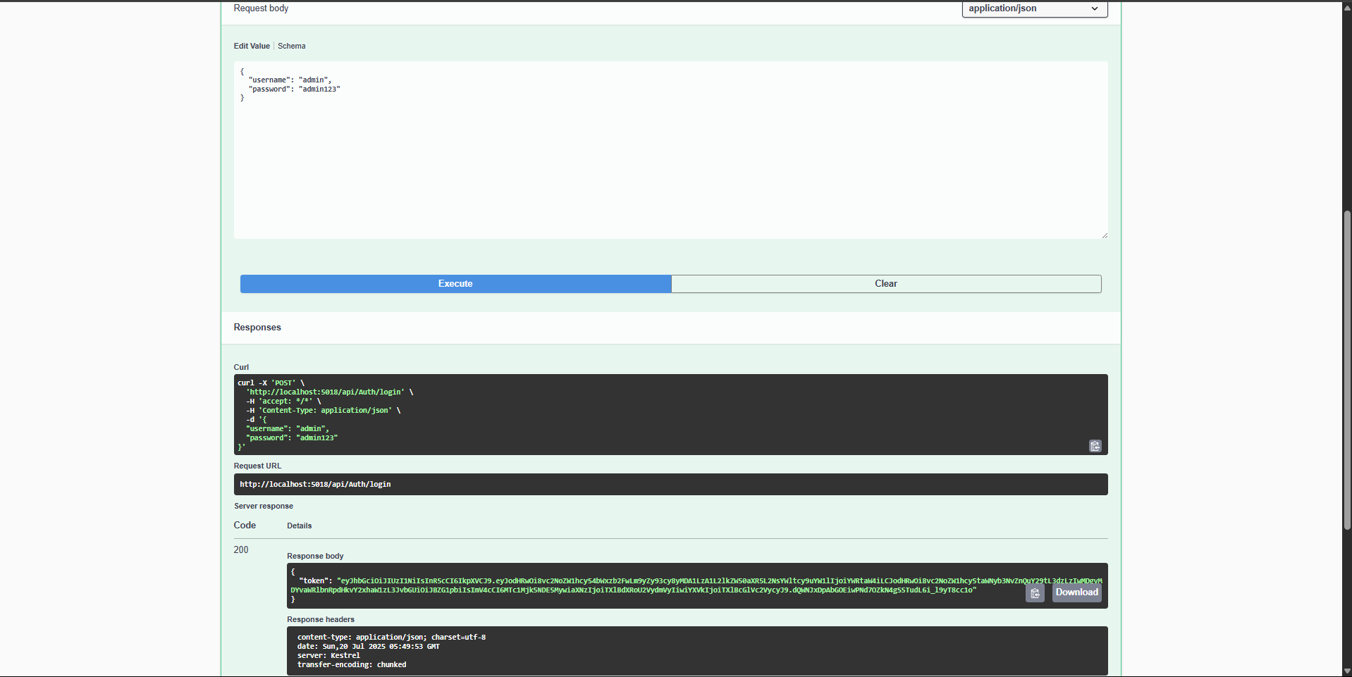
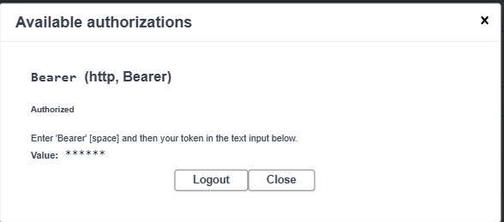

Using POSTMAN:
